**ARYAMAN MISHRA**

**19BCE1027**

SCAPY

Website: http://www.testingmcafeesites.com/

identify the http site and provide the URL



identify the subdomains

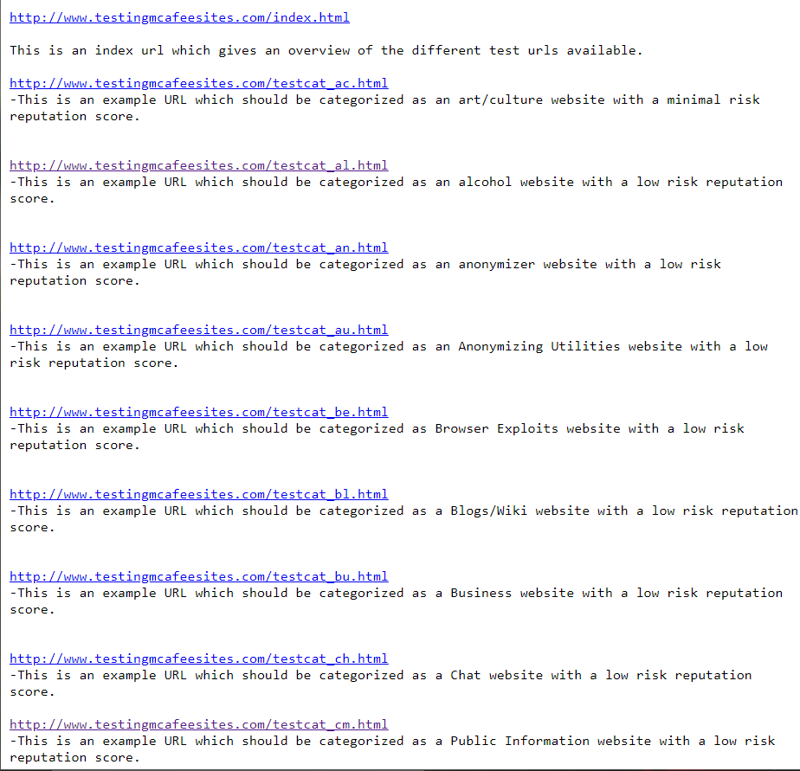

similar to output of WHO IS command , write a program for the same in scapy

check the route of the provide URL using scapy

Provide the packets sent and received summary using SCAPY, store the contents using PCAP file

Analyze the file , i.e find the no. of TCP,UDP packets etc , provide summary of it

Display the domains and nameserver